A

PROJECT REPPORT

ON

HANGMAN GAME

submitted in partial fulfillment of the requirement of the degree of

**BACHELOR OF ENGINEERING**

**IN**

**COMPUTER ENGINEERING**

BY

Armaan Nakhuda (20220164402277961)

Sushant Navle (2022016402277791)

Samay Pandey (202216402279163)

Guide:

Prof. Irin Solomon



**Department of Computer Engineering**

K.C. College of Engineering and Management Studies And

Research, Thane (E)

University of Mumbai

2023-24

CERTIFICATE

This is to certify that the skill lab mini project entitled “HANGMAN GAME’’ is Bonafide work of Armaan Nakhuda (B-02), Sushant Navle (B-05), Samay Pandey (B-09) submitted to the University of Mumbai in partial fulfillment of the requirement for the award of the degree of “Bachelor of Engineering in Computer Engineering”.

Guide

Prof. Irin Solomon



Head of Department Principal

Prof. Mahesh Maurya Dr. Vilas Nitnavare

**Project Report Approval for S.E.**

This mini project entitled ***HANGMAN GAME*** by ***Armaan Nakhuda (B-02); Sushant Navle (B-05); Samay Pandey (B-09)*** is approved for the degree of Bachelor of engineering in Computer Engineering.

Examiners

1..............................................................................

(Internal Examiner Name & sign)

2.....................................................................

(External Examiner name & sign)

Date: -

Place: -

**ACKNOWLEDGEMENT**

We would like to express special thanks of gratitude to our guide **Prof. Irin Solomon** whogave us the golden opportunity to do this wonderful project on the topic of HANGMAN GAME, which also helped us in doing a lot of research and we came to know about so many new things. We are very grateful to our Head of the Department **Prof. Mahesh Maurya** for extending his help directly and indirectly through various channels in our project work**.** We would also like to thank Principal **Dr. Vilas Nitnaware** for providing us the opportunity to implement our project. We are really thankful to them. Finally we would also like to thank our parents and friends who helped us a lot in finalizing this project within the limited time frame.

Thanking You.

Contents

Abstract

List of abbreviations

List of figures

1. Introduction

1.1 Introduction

1.2 Motivation

1.3 Problem Statement & Objectives

2 . Mini Project contribution

3 . Proposed System

3.1 Introduction

3.2 Architecture or Framework

3.3 Details of hardware and software

3.4 Experiment and Results

3.5 Conclusion and future work

4 . References

1

List Of Figure

|  |  |  |
| --- | --- | --- |
| Figure  no. | Figure Name | Page no. |
| 1. | Flowchart | 11 |
| 2. | Start Game Screen | 13 |
| 3. | Main Game Screen | 14 |
| 4. | Losing Screen | 15 |
| 5. | Winning Screen | 19 |
| 6. | Give Up | 20 |
| 7. | Restart Game | 21 |
| 8. | Add Word | 22 |
| 9. | Remove Word | 23 |

2

Abstract

This project introduces a Hangman game developed in Python with the PyQt5 library for the user interface and Firebase as the backend database for word storage. Hangman is a classic word-guessing game where players attempt to guess a word by suggesting letters within a limited number of attempts.

PyQt5 facilitates the creation of an interactive graphical user interface for seamless gameplay. Players are presented with a blank word to guess and a set of letters to choose from. As they make guesses, the interface dynamically updates to reveal correct letters and display the hangman figure for incorrect ones.

Firebase serves as the database backend, storing a diverse collection of words for the game. This integration ensures a varied selection of words, enhancing the game's replay ability across different difficulties.

The project demonstrates the integration of Python, PyQt5, and Firebase to create an engaging gaming experience. By leveraging cloud-based word storage, players can enjoy a continuously updated pool of words, adding depth and challenge to each gameplay session. This implementation highlights the synergy between modern technologies in game development, offering a glimpse into the potential of combining cloud services with graphical interfaces for enhanced user experiences in gaming applications.

3

List Of Abbreviation

List of Abbreviations for HANGMAN GAME:

1. GUI: Graphical User Interface
2. CPU: Central Processing Unit
3. UI: User Interface
4. SP: Single Player
5. DB: Database

This list provides a quick reference to the abbreviations used in the HANGMAN GAME

4

INTRODUCTION

1.1 Introduction

The Hangman Game with Python, PyQt5, and Firebase Integration is a modern rendition of the classic word-guessing game, designed to offer an engaging and interactive gaming experience. Developed using Python, PyQt5, and Firebase technologies, this project brings together a blend of programming prowess and contemporary database management.

With PyQt5 as the framework for the graphical user interface (GUI), players can enjoy a visually appealing and intuitive interface, allowing seamless interaction with game elements such as masked words and letter selection buttons. Firebase integration serves as the backbone of the game, providing a dynamic repository of words for gameplay. This integration ensures a constantly evolving word pool, enriching the gaming experience with a diverse range of words across various categories.

5

1.2 Motivation for Creating A HANGMAN GAME

The motivation behind creating the Hangman Game in Python stems from a desire to combine classic entertainment with modern technology. By implementing the game using Python, we aimed to showcase the language's versatility and ease of development, making it accessible to both novice and experienced programmers. Additionally, integrating PyQt5 for the graphical user interface and Firebase for word storage adds depth and dynamism to the gaming experience, aligning with contemporary trends in software development. Ultimately, this project serves as a testament to the creative potential of Python and its ability to breathe new life into timeless pastimes like Hangman.

6

1.3 Problem Statements and Objectives

Problem Statements: -

In contemporary gaming environments, the Hangman project tackles several key challenges prevalent in traditional game development practices, impeding efficiency and hindering optimal gameplay experiences. Below are some problem statements specific to the Hangman project:

1. **Manual and Tedious Gameplay Mechanisms:** The Hangman game relies on manual processes for tasks such as word selection, letter masking, and user interaction, leading to inefficiencies and sluggish gameplay. Manual handling of these tasks not only increases the likelihood of errors but also diminishes the overall enjoyment and engagement of players.
2. **Fragmented Data Management:** Existing Hangman implementations often lack centralized data management, resulting in scattered word repositories and disjointed gameplay experiences. This fragmentation leads to difficulties in maintaining a cohesive collection of words and extracting meaningful insights for enhancing gameplay dynamics.
3. **Limited Word Diversity:** Many Hangman implementations suffer from a limited pool of words, leading to repetitive gameplay experiences and reduced player engagement. The absence of a diverse range of words hampers the game's replay value and fails to cater to the varied preferences of players.

7

Objective: -

The objectives while creating the Hangman game were:

1. **Entertainment:** The primary goal is to provide players with an enjoyable and engaging gaming experience. The game should be entertaining, immersive, and capable of captivating players' attention for extended periods.
2. **Education:** Hangman can serve as an educational tool for improving vocabulary, spelling, and language skills. Incorporating diverse word categories and difficulty levels helps players learn new words and concepts while having fun.
3. **Challenge:** The game should offer an appropriate level of challenge to keep players motivated and engaged. Balancing difficulty levels, providing incentives for progression, and offering hints or assistance when needed are crucial aspects of maintaining player interest.

8

2.Mini Project Contribution

There as an equal contribution to this project giving new ideas, proposing the designs, and adding the content to it, gathering information, coding &execution the final result.

9

3.Proposed System

3.1 Introduction

The Hangman project is a Python-based game tackling challenges in traditional game development. It automates gameplay, centralizes data management, enhances word diversity, and optimizes user experience. By addressing these issues, it aims to offer an engaging and seamless Hangman gaming experience for players across different platforms.3.2 Architecture

The architecture behind a Hangman game typically involves several key components:

1. **User Interface (UI):** The UI is responsible for presenting the game to the player and facilitating interactions. It includes elements such as the game board, letter buttons for guessing and visual representation of the hangman.
2. **Word Database:** A word database stores the words that players will guess during the game such as a predefined list of words, a pre-generated list based on difficulty levels.
3. **Game Logic:** The game logic handles the core functionality of the game, including word selection, letter validation, updating the hangman's visual representation, tracking the player's progress, and determining the outcome of the game (win, loss, or ongoing).

10

Flowchart: -

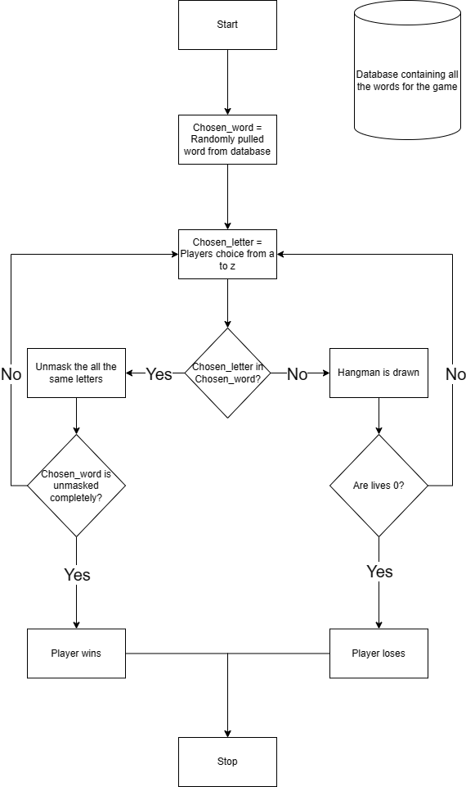

Figure 1

Figure 1 is a flowchart of the basic showcase of HANGMAN GAME.

1. Initialization: When the player starts the application, the game is started and the first word is automatically pulled from the database.
2. Database: It holds all the words used in the game.
3. Buttons: Letters from A to Z are provided so the user can select any letter they want, Extra buttons are also provided to add/remove words from the database, to reset the game or give up.
4. Outcome: Based on the winning or losing of the player the toast is displayed.

11

3.3 Hardware And Software Requirements: -

Hardware :-

1. Minimum Requirements:
2. Processor:- Dual core processor @2.4Ghz
3. Ram:- 4GB Ram
4. Storage:- 2GB free space
5. Recommended Requirements:
6. Processor:- Quad core processor @2.8Ghz
7. Ram:- 8GB Ram
8. Storage:- 4GB free space

Software :-

1. Minimum Requirements:
2. OS: Windows 10 22H2
3. Python version 3.11 with firebase and PyQT5 modules installed.
4. Recommended Requirements:
5. OS: Windows 11 22H2
6. Python version 3.12.3 with firebase and PyQT5 modules installed.

12

* 1. Experimental Result: -

Start Game Screen: -

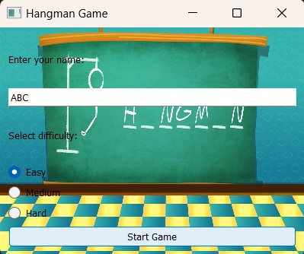

Figure 2

In figure 2:- This the main login screen for the game as shown in the figure 2 and it consists of your username and the selection of difficulty; Ranging from easy-medium-hard. By clicking on start you can enjoy playing the game.

13

Main Game Screen: -

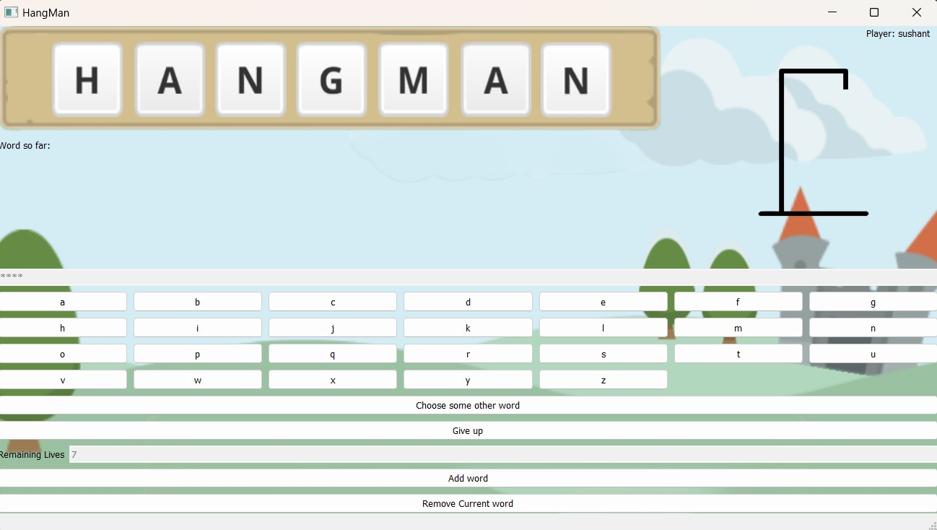

Figure 3

In figure 3: - As we can see here, we have the main screen for the game which involves our username on the right corner; and has all the letters from A-Z to guess the word to fill in the blank characters above. To the bottom-left we have a count of remaining lives to complete the game. In this interface all buttons have separate functions respectively. The Model without the stickman shown is the default state for the adaptive images based on the game state.

14

Losing Screen: -

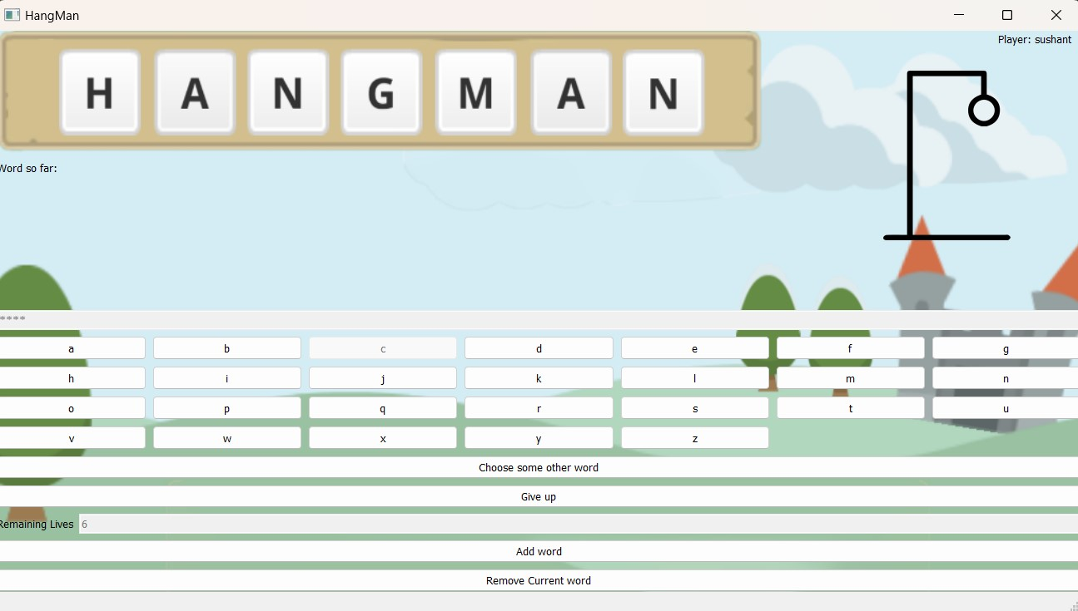

Figure 4

In Figure 4:- If you select an incorrect letter here, in that case you would lose 1 life and a head would appear on the right corner of the screen.

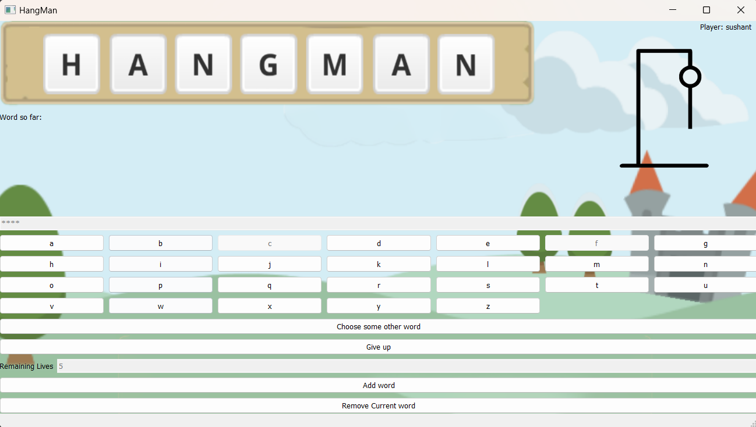

Figure 5

In Figure 5:- If you select 2 incorrect letters, you would lose 2 lives and head along-with body would appear.

15

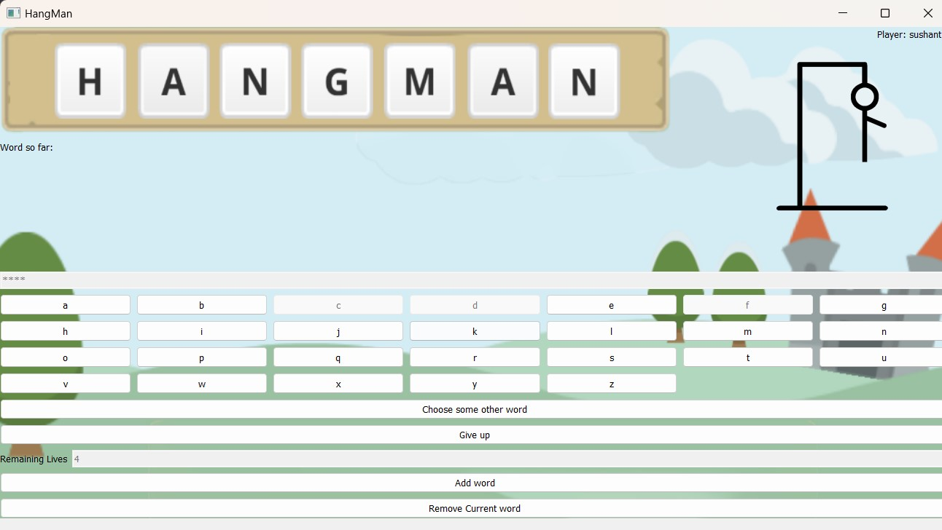

Figure 6

In Figure 6:- If you make 3 incorrect selection, you lose 3 lives and appearance of head-body-and a right hand would be seen.

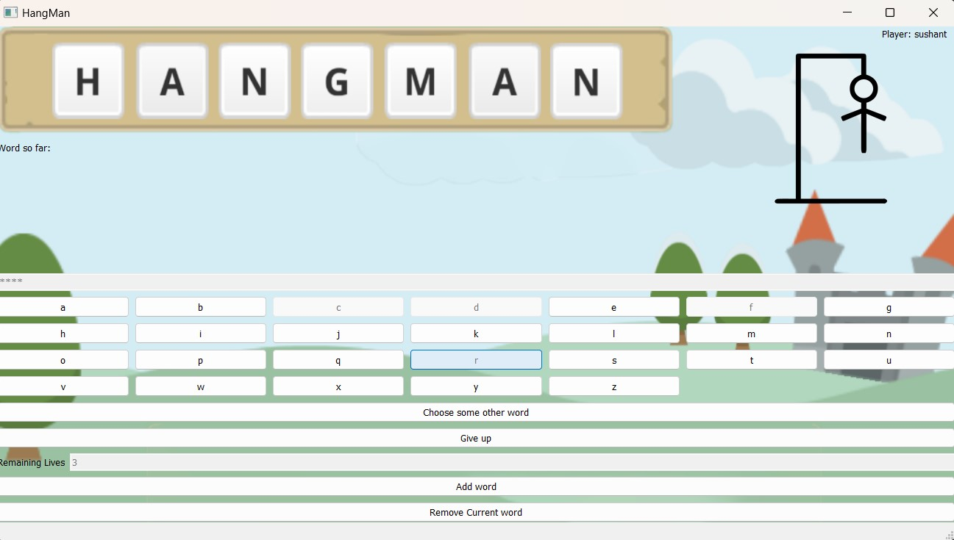

Figure 7

In Figure 7:- If you make 4 incorrect selection, you lose 4 lives and appearance of head-body-and both hands would be seen.

16

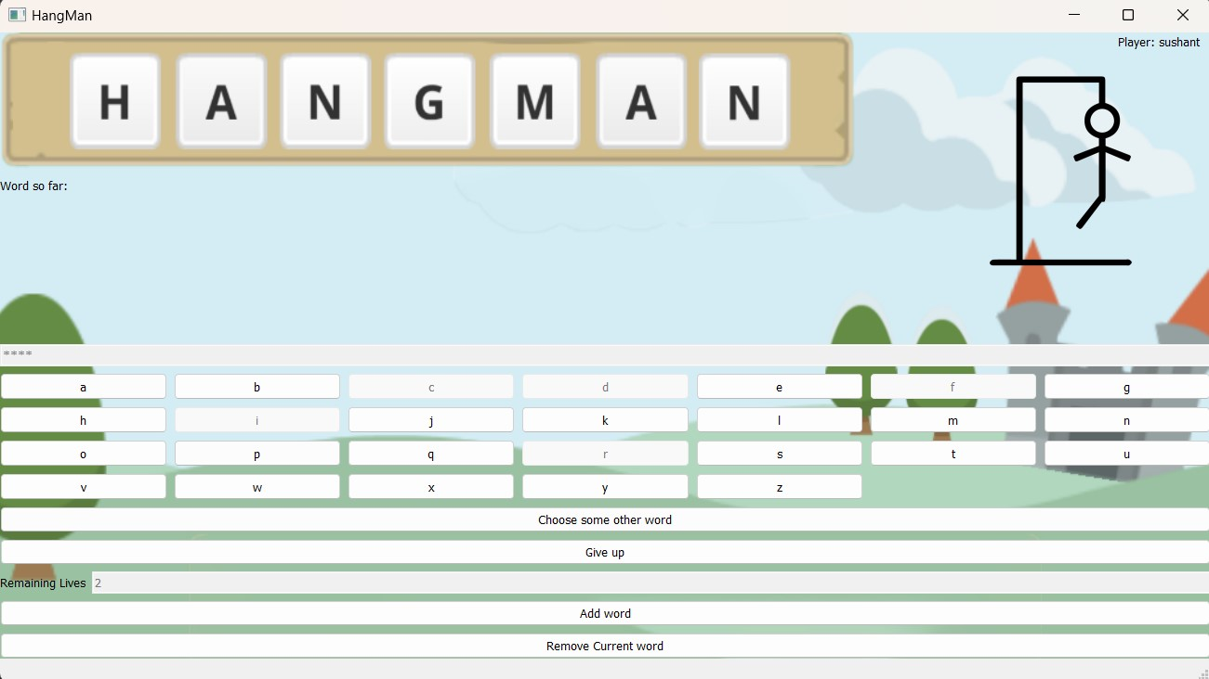

Figure 8

In Figure 8: - If you make 5 incorrect selections, you lose 5 lives and appearance of head-body-both hands-and a leg would be seen.

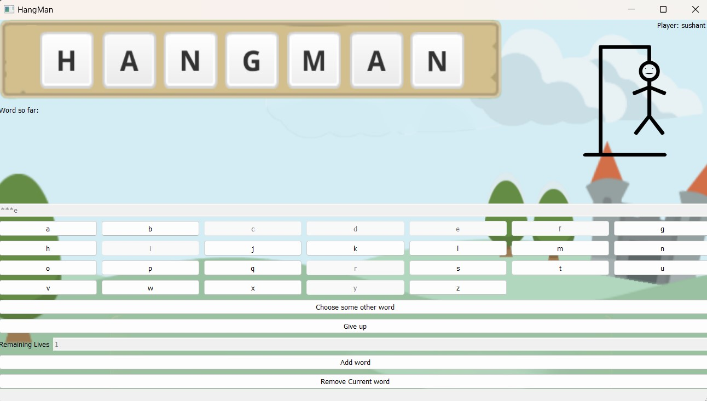

Figure 9

In Figure 9: - If you make 6 incorrect selections, you lose 6 lives and appearance of head-body-both hands-both legs would be seen.

17

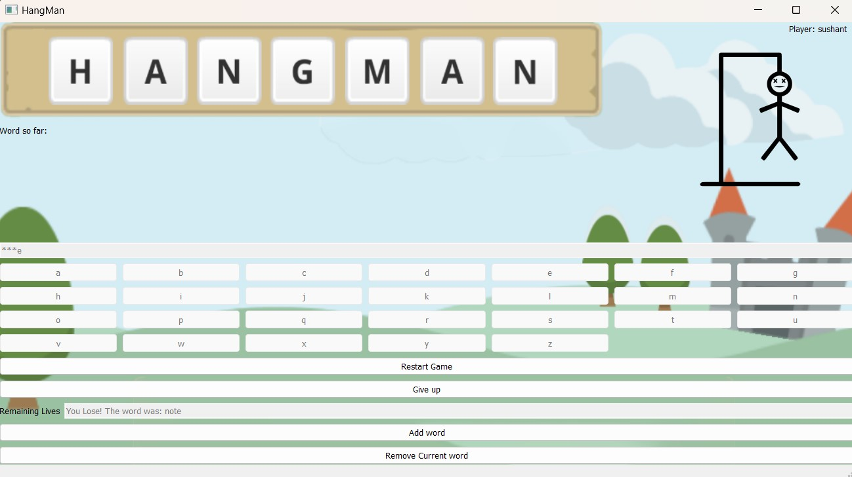

Figure 10

In Figure 10: - If you make all letters incorrect you lose all lives making the hangman completely dead which would be seen on the top right corner, and you would be displayed the losing toast along with the answer.

18

Winning Screen: -

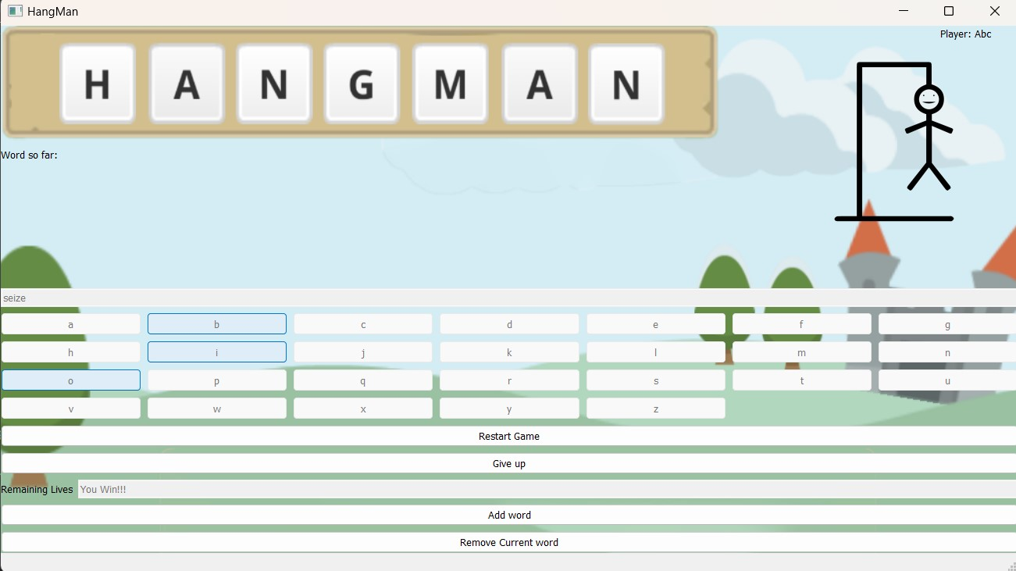

Figure 11

In Figure 11: - If you guessed correctly one by one and fill in the asterisk, you won’t lose any lives and be able to see the word. The count of lives will be changed to – “You Won!!!”.

19

Give Up: -

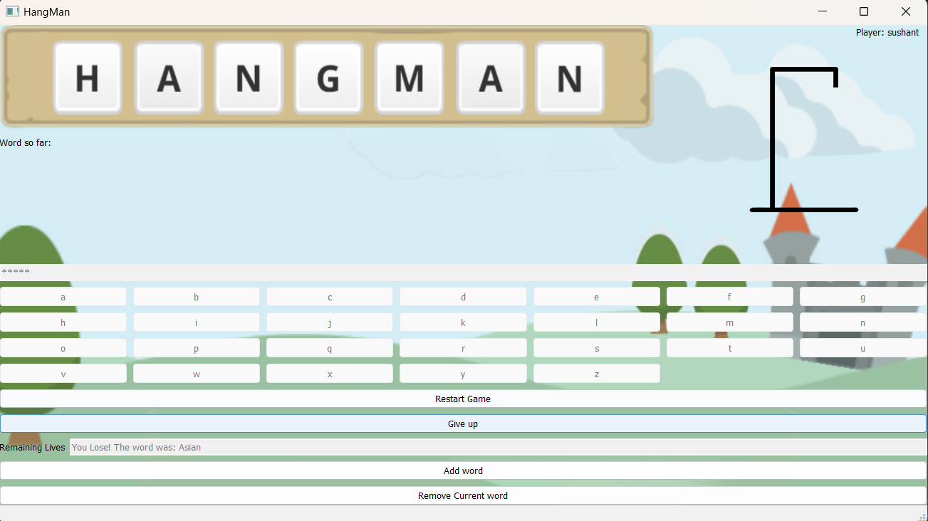

Figure 12

In Figure 12: - If you click on the give up option you loose and you would be displayed the word on the option of life count along with “you lose” statement.

20

Restart Game: -

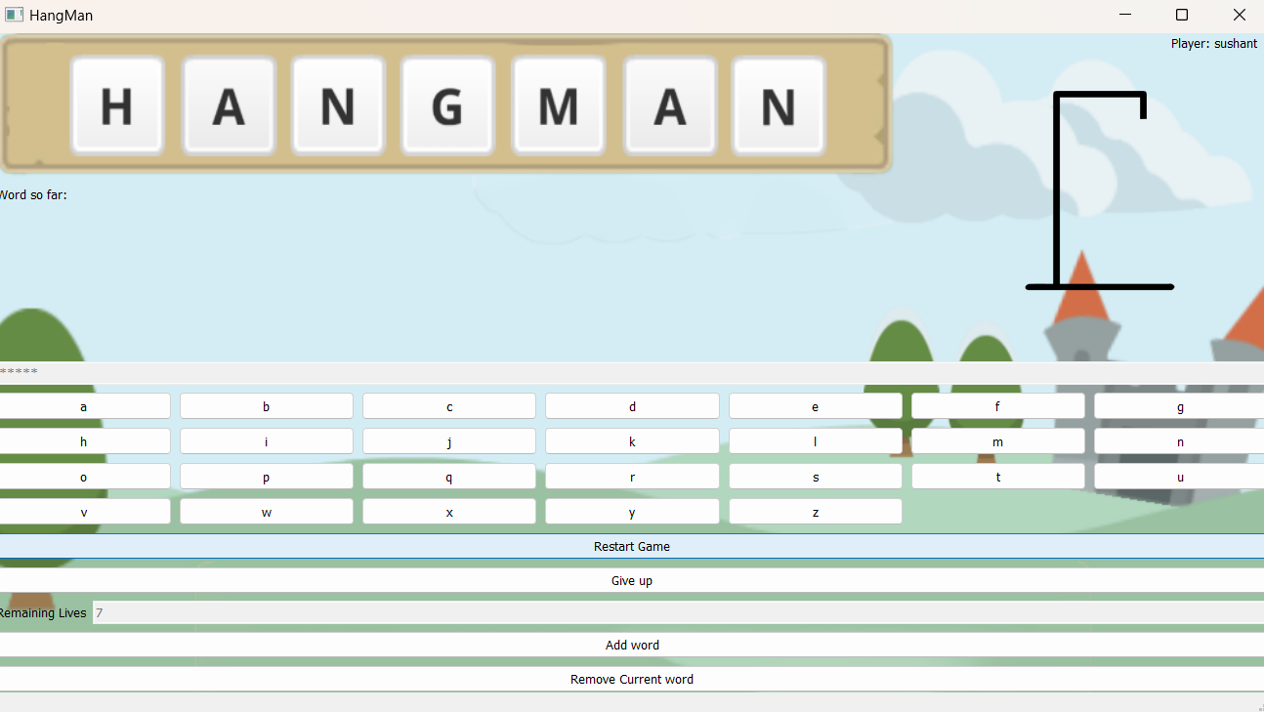

Figure 13

In Figure 13: - When you click on restart game you would see that the game begins again from the beginning and there would be a new word to guess with resetting the life count and the hangman animation.

21

Add Word: -

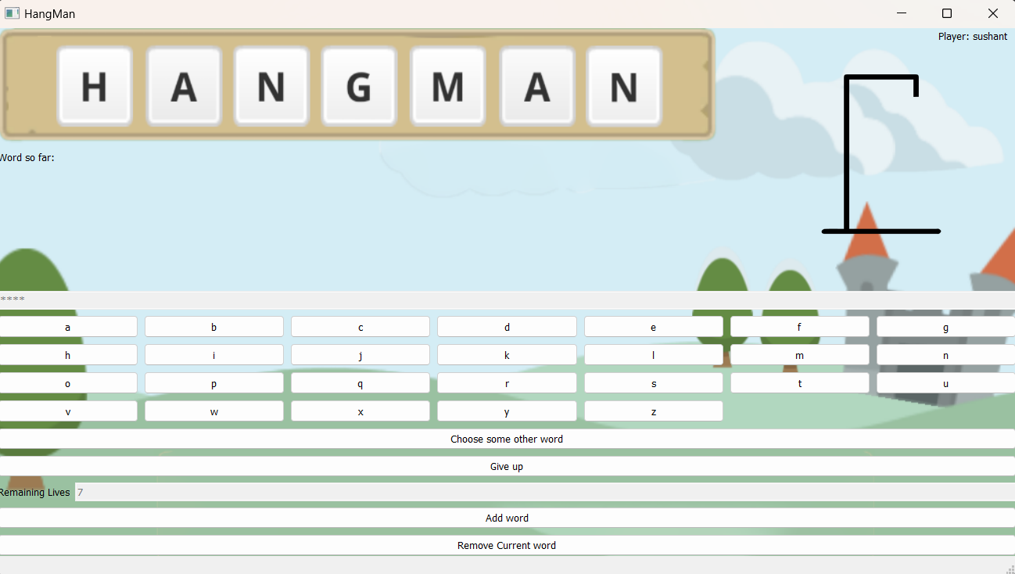

Figure 14

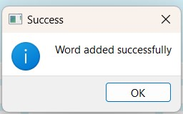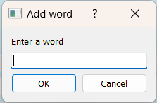

Figure 15 Figure 16

In the above Figures: - In figure 14 if you click on the option add the word you get a pop-up as shown in figure 15 to add an additional work. After you add the word into the database you see the pop-up of success as indicated in Figure 16.

22

Remove Word: -



Figure 17

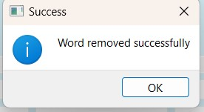

Figure 18

In above Figures: - In figure 17 if you click on “remove current word” option it will remove the current word from the database with the pop-up displaying it (as shown in figure 18) and the game will restart with new lives and new word to guess.

23

3.5 Conclusion and Future Scope: -

Conclusion:-

In conclusion, Hangman remains a timeless favourite, blending simplicity with challenge and educational value. It fosters language skills and strategic thinking. With its enduring appeal and innovative design, Hangman stands as a testament to the power of classic entertainment in the digital era, bringing joy.

Future Scope:-

The future scope of the Hangman game is promising, with opportunities for expansion, innovation, and adaptation to emerging technologies and trends. Here are some potential areas for growth:

1. **Enhanced Gameplay Features:** Introducing new gameplay mechanics, such as power-ups, special abilities, or alternative game modes, can add depth and variety to the Hangman experience. These features could offer players additional challenges or strategic options to explore.
2. **Advanced AI and Personalization:** Implementing AI-powered opponents or personalized game experiences tailored to individual players' preferences and skill levels could elevate the gameplay experience. Adaptive difficulty levels, intelligent hints, and dynamic word selection algorithms can make the game more engaging and immersive.
3. **Educational Applications:** Further exploring the educational potential of Hangman by partnering with educational institutions or integrating curriculum-aligned content can position the game as a valuable learning tool. Incorporating language learning exercises, vocabulary quizzes, or themed word packs can make Hangman more appealing to educators and students alike.
4. **Monetization and Business Models:** Exploring alternative monetization strategies such as subscription services, in-game purchases for cosmetic items or premium features, or ad-supported free-to-play models can diversify revenue streams and sustain the game's development and growth.

24

REFERENCE

* 1. ChatGPT (OpenAI):
     1. Useful for resolving technical issues and bug fixes during the project development process.
     2. Website: [OpenAI](https://www.openai.com/)
  2. GeeksforGeeks:

1. A valuable resource for generating ideas, solutions to coding challenges, and technical insights.

Website: [GeeksforGeeks](https://www.geeksforgeeks.org/)

* 1. YouTube:

1. A platform to explore a wide range of video tutorials, demonstrations, and insights related to mobile game development and user interface design.

Website: [YouTube](https://www.youtube.com/)

* 1. StackOverFlow:  
     A community-based space to find and contribute answers to technical challenges, and one of the most popular websites in the world.
  2. GitHub:  
     It is a developer platform that allows developers to create, store, manage and share their code. It uses [Git](https://en.wikipedia.org/wiki/Git) software, providing the [distributed version control](https://en.wikipedia.org/wiki/Distributed_version_control) of Git plus [access control](https://en.wikipedia.org/wiki/Access_control), [bug tracking](https://en.wikipedia.org/wiki/Bug_tracking_system), [software feature](https://en.wikipedia.org/wiki/Software_feature) requests, [task management](https://en.wikipedia.org/wiki/Task_management), [continuous integration](https://en.wikipedia.org/wiki/Continuous_integration), and [wikis](https://en.wikipedia.org/wiki/Wiki) for every project.

25